PCB Synergy Users Guide Beta.doc
This Application is a file generator for various Surface Mount Machines. As well as a BOM (Bill of Materials and Costs) generator its interface is thus designed a little differently to a standard Windows Application. With the File generator paradigm in mind, the initial Screen you see is the file input and output locations. You initially set these up and then move to the second screen, which sets the Options you, may wish to select. Next you hit the Process button which is on both the Files and Options screens for convenience. This will then generate all the output files. You may then want to add costs to the output files. You then go to the Library screen to do this by importing component costs in an Excel CSV file. Another dialog exists for generating Board Offsets (The Origin Calculator). This application was designed for the small Electronics establishment that may have only one standalone SMT machine. It aims to make the organization of ordering, purchasing and setting up an SMT machine less painful. Since it uses CSV files for its cost setup, it is not a replacement for a fully blown MRP (Material Resource Planning) Database or a multi-machine SMT line file generator.

Files Screen

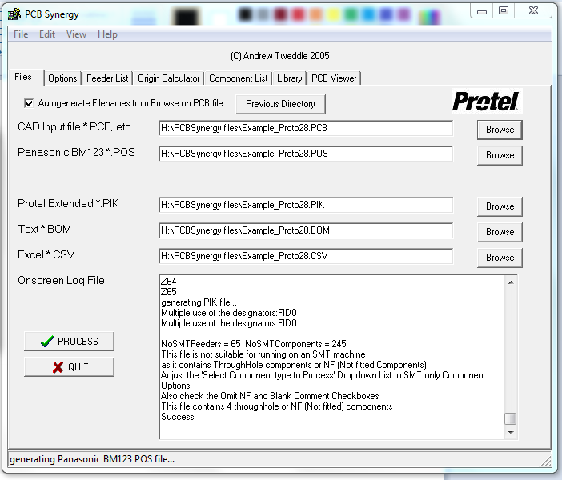
This Screen sets up the output locations for the files generated by PCBSynergy as well as the Protel PCB, PIK, Schematic file to be read. If a Schematic file is read then no valid SMT machine file is generated. The Auto generate Filenames from Browse on PCB file is selected by default. It places output files in the same folder by default. Simply type where you require your output directories or select with the corresponding Browse button. If there is a filename conflict, ~2 is automatically added to the generated name. It has a window that displays a log of files processed. It also has the Process button for file generation. Process options however have to be set on the Options Screen.

Open Browse Dialog
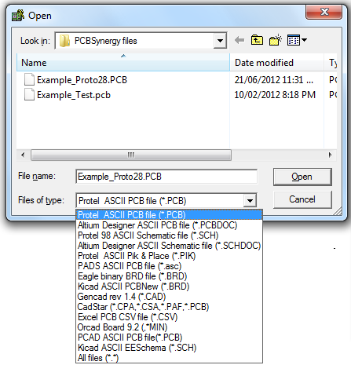

This Open Browse Dialog has Options for Protel ASCII PCB files which include Autotrax, Protel 2.8 Protel 98, Altium Designer PCBDOC files again in ASCII, Protel 98 Schematic files, Altium Designer Schematic files. As well as Protel PIK files. There are limitations with the PIK file, as it doesn’t support component sizing, as it has no Pad data, other than component centre locations. Consequently the DPAK and other component centre fixing can’t work. Several new PCB readers have been developed for release 1.0.0.16 specifically GenCAD *.CAD, Cadstar *.PAF , *.CPA and *.CSA, OrCAD *.MIN, and PCAD *.PCB. and Eagle XML *.BRD
The Schematic files as they have no board information cannot generate a useful SMT file.

Now PCBCSV reading has been added, this is similar, but more generic than the PIK reading. The following Column names are required (but only one for each description type)
Designator, Refdes, CompID, x, y, refx, refy, midx, midy, padx, pady, comment, pattern, component, feeder, locationx, locationy, rotation, angle, layer, TB

An example file

RefDes,Pattern,Comment,Layer,LocationX(inch),LocationY(inch),Rotation
C1,1608,100nF,Top,2.920,6.730,180
C2,1608,10nF,Top,4.780,6.840,180
C4,805,18pF,Top,1.200,6.640,180
D10,3.5X2.8X1.9,Orange_LEDTop,5.600,6.910,0
U11,TO-220V,LM317,Top,12.320,6.880,0
U7,LLP10-50,TPS61200,Top,4.100,6.880,0

or an internally generated file from Options->Test->Excel PCB CSV *.CSV

Designator, Pattern, Comment, Mid X, Mid Y, Ref X, Ref Y, Pad X, Pad Y, TB, Rotation
R37,1608, 0.00 ,79.45mm,50.30mm,79.45mm,49.55mm,79.45mm,49.55mm,T,90.00
R18,2012,22.00m,96.20mm,59.31mm,95.20mm,59.31mm,95.20mm,59.31mm,T, 0.00
R44,2012,22.00m,93.59mm,22.32mm,94.59mm,22.32mm,94.59mm,22.32mm,T,180.00
D2,3.5X2.8X1.9,Orange_LED,39.80mm, 5.40mm,39.80mm, 5.40mm,39.80mm, 6.90mm,T,270.00
D4,3.5X2.8X1.9,Red_LED,35.40mm, 5.40mm,35.40mm, 5.40mm,35.40mm, 6.90mm,T,270.00
U2,TQFP80P1200X1200-44AL,ATMEGA324,43.80mm,57.40mm,43.80mm,57.40mm,47.80mm,63.00mm,T,270.00
U3,QFN-32,CC1020,66.43mm,54.96mm,66.43mm,54.96mm,63.98mm,56.71mm,T, 0.00

As you may have noted the measurement units (mm, mils, inch) are either next to the Column heading (something that can be easily Hand edited) or next to every instance in the rows (something probably computer generated). With version 1.0.0.16 reading a Comment line before the main body of the file can also read the unit type .

# Created by VisualPlace version 2.0.5140 at Fri Oct 31 16:46:17 2014
# Report origin: (0.0/0.0) = lower left corner of PCB
# Units: inch
"Designator","Value","X","Y","Rotation","Side","Package"

"C8","100.00n","3.8252","3.1000","270.0","Top","1206"
"C9","100.00n","4.5551","3.2650","180.0","Top","1206"

A bug/design oversight has been discovered in the existing Ver 1.0.0.10c wear the second line of the Test->Excel PCB CSV *.CSV file is blank and this causes reading failure, removing this line and reading works!

The order of the Columns is not critical!! So you don't have to spend half an hour reordering the columns in a spreadsheet.

Just added in Version 1.0.0.11 are file readers for Eagle Binary, PADS ASCII, and Kicad ASCII formats. None of these formats have footprint correction at this point in time. This problem can be over come by taking the PIK or PCBCSV output and hand editing the file in Excel ( or your favorite spreadsheet). Then re-importing the corrected file. You will need to add board dimensions in the Origin Calculator tab, if you use this approach.

If you don't use Protel as your primary CAD package there are a number of packages that can convert to a Protel file, so you can use PCBSynergy. Specifically EAGLE with its ULP based file converters. http://www.cadsoftusa.com/cadsoft-downloads/

Save Browse Dialogs
The Save Browse Dialog similarly to the Open Dialogs allows Files of the specific type to be viewed when saving a file. The file extensions change to suit the machine type being saved.

Options Screen
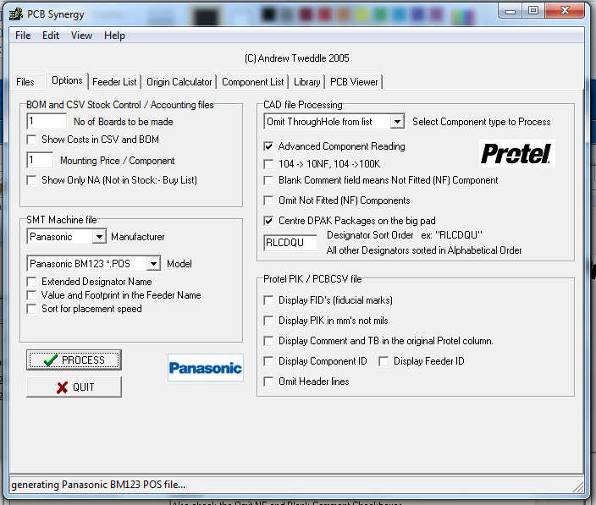

This Screen has all the Options for the various files that get generated by PCBSynergy.

There is a Combo Box (Select Component type to Process) for omitting various types of components from the generated files. Its Options are - Include all the components, Omit through-hole components, Surface-Mount top layer, Surface Mount Bottom Layer, Through-hole. PCBSynergy reads the incoming PCB file and works out whether a component is through hole or surface mount and on which layer the component is placed. Note the Protel PCB format doesn’t have an explicit field for this, so we have to calculate this from the component footprint, something which would normally have to be corrected by hand when generating a Pick and Place file for an SMT machine. Be Aware, when swapping Bottom to Top layer you may loose your feeder list for no seemingly logical reason. Similarly your BOM, CSV, PIK and SMT files.

Blank Comment field means NF (not fitted). This is fairly obvious.

Omit Not Fitted (NF) Components. This means that if a component is not fitted on this board then a line in the BOM, CSV and PIK file for it is omitted.

Display FID’s (fiducial marks) in the PIK file. If your board is setup to be made with an SMT machine then usually you would place 2 fiducial marks on each board (3 for Juki/Zevatech machines) and then maybe some on the Panel (Multiple boards would normally go on a panel). The FID is a Pad or a Component labelled FID in its Comment field.

Centre DPAK’s and TO220’s type Packages on the big Pad. Traditionally Protel has calculated the centre point of the component as the middle of all Pins, this works fine except for these packages. The centre point in these cases is often in mid air and so the components fail to be picked up. This option fixes this problem. This only works when a file is read from the PCB.

Display PIK in mm’s not mils. This is fairly obvious but it does allow for SMT machines that may work only in an imperial or metric mode. This is useful when your SMT machine isn’t in the SMT Machine Type List.

Display PIK Comment and TB in the Original Protel column for compatibility.

Display Component ID in the PIK file. This Option can be useful for SMT machines that require no’s for component identification.

Display Feeder ID in the PIK file. This Option can be useful for SMT machines that require no’s for feeder identification.

Omit header lines in the PIK file for compatibility with your SMT machine.

Read Schematic Sub sheets ( This Option is only visible when reading a Schematic file) It will read all the files in the Schematic Hierarchy to simulate the complete board file (minus XYR's) This Option is used when you would like to set up feeder lists and BOM files before you have finished the board. .It also helps in pre-production costing.

Show Only NA (Not Available in Stock) Components in generated BOM and CSV
This Option is useful for ordering components. A Stock library file is read and a costing file generated to use this option. Then only the components you need to order are in this list.

Designator Sort Order. This option allows all output formats to be sorted by designator type, in any order specified by the user. For example, “RLCDQU” sorts resistors, inductors, capacitors, diodes, transistors, IC’s in that order in the list. After this other designators are sorted alphabetically if not specified. Also resistors, inductors and capacitors are sorted in an ascending real number equivalent way so 1,2,10,20,100,200,1k, 2k not 1,10,100,2,20,200,2k like many other programs. IC’s are sorted in string order. Ex: LM319, LM339 etc. This makes it easier to sort through boxes of component reels that are sorted in this way.

The SMT Machine Manufacturer has Options for :- APS Novastar, Access MS, Essemtec, Fuji, Gencad, Juki, Manncorp, Mirae, MyData, Panasonic, Philips, Samsung, Sanyo, Siemens, Test, Unicam, Yamaha/Philips, Zevatech/Juki , PCBSynergy CSV.
The PCB Synergy CSV format is under the control of the PIK controls, for generating a file for a machine not supported by this program.

The SMT Machine Model has a number of models from each manufacturer listed.

These files are not guaranteed to be correct at this point in time. Any suggested fixes are most welcome. Most of the formats were developed by reverse engineering, as manufacturers do not always seem to be willing to give out their formats which they regard as closed to external software developers. (But they will often disclose to machine owners, as they try not to piss off their customers)

The SMT Machine file has been modified to cope with the growing number of formats this software interfaces to. Other Checkboxes will be added for left to right and other configuration options for machines as the data becomes available.

The Checkbox for Value and Footprint was added to cope with a generalised way of dealing with machine feeder configuration naming. It is not yet implemented in all models as all output formats have to be rewritten which is a large job.
The changes in this lead me to rewrite the Files SMT output options as well as the Browse Save options for a simpler and more consistent set of save options

Sort for placement speed. This checkbox only impacts in a few of the higher speed machines like Yamaha YV/YP/YG with multiple heads. If you have a desktop or older single head machine, the one thing you can do to increase volume is to move your high volume components, to the feeder with the shortest path length to the board.

Feeder List Screen
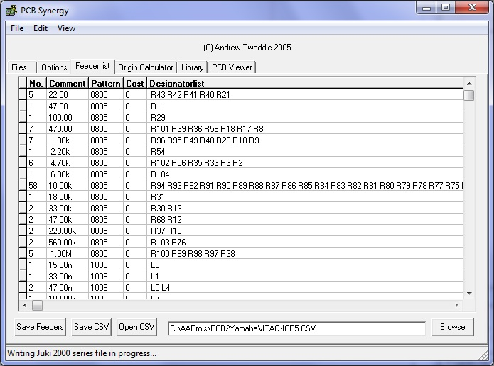
This Screen contains the generated feeder list for onscreen viewing. To generate this file you must select your Options on the previous Options screen and then click the Process button. This generates the necessary output files as well as this list.
If you want costings, then you must add this by going to the Library dialog and opening a library file and clicking the Update Feeder list button. This will save these changes in your BOM, CSV and PIK files. The Save CSV button just saves this list as it is to the file in the file box. This list can be used to generate a customer library. By adding a Cost column to the CSV file. Just added in Version 1.0.0.16 the Designator list is sorted.

The Feeder List can now resort the individual feeders using cut and paste from the Edit menu. It uses the usual windows shift select to gather up the feeders you wish to move, and then Ctrl C to select, then you move the cursor to the appropriate line, then select paste or paste Insert etc. You may also export the feeder list to Excel using the save CSV Option, Edit the list in Excel, and then re-import it using the Open CSV. You then use the Save Feeders button to commit your changes to the Files Dialog save settings( SMT Output file). This feature was a long time coming and necessitated an awful lot of coding. More work has been done on the OpenCSV and SaveCSV. These options now import and export the Feeder No, So that the Feeder locations can be easily edited, and then re-imported. Once this is done hitting the SaveFeeders button generates new SMT files with your feeders now moved.

New Fixed Feeders Tab

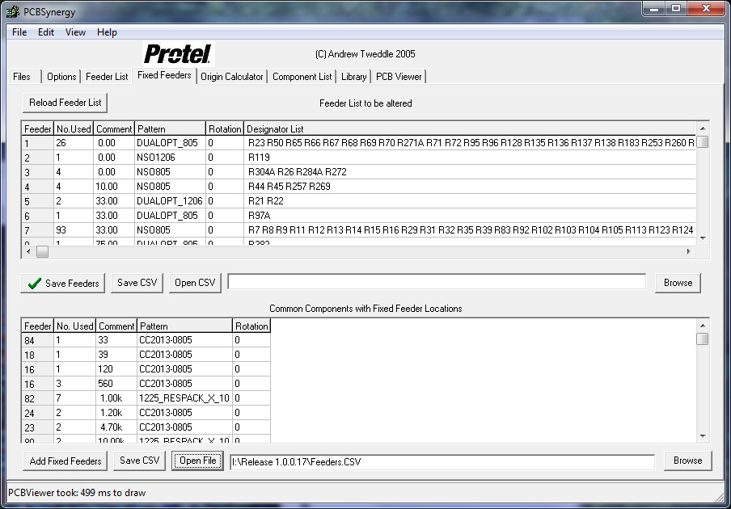
This new Tab better handles Feeder movement than the previous Feeders List. It does this by adding an extra List for Fixed feeders. You can import a CSV using the Browse dialog to select the Feeders file. Then Open that file using the Open Button. You may now edit the List including the Feeder No. Comment and Pattern and if necessary resave the file. Next you hit the Add Fixed Feeders button which will update the feeder No. in the Feeder List above. You can further edit this list like the bottom list and finally save it to the Output files by clicking on the Save Feeders button. If you are unhappy in your changes you can reload a copy of the original generated file using the Reload Feeder List button. This feeder List can also be saved or loaded by editing the Memo Box or browse for a new file and then selecting an existing file to overwrite or generating your own new file.

Tray Feeding

This feature hasn’t been released, as it is something that is relatively hard to collect manufacturers’ data for. Also most machines do not have a relatively standard way of placing trays on a machine instead using low volume custom built feeders. Some users cobble together fixed plates and then hand swap trays in and out.

Origin Calculator Screen

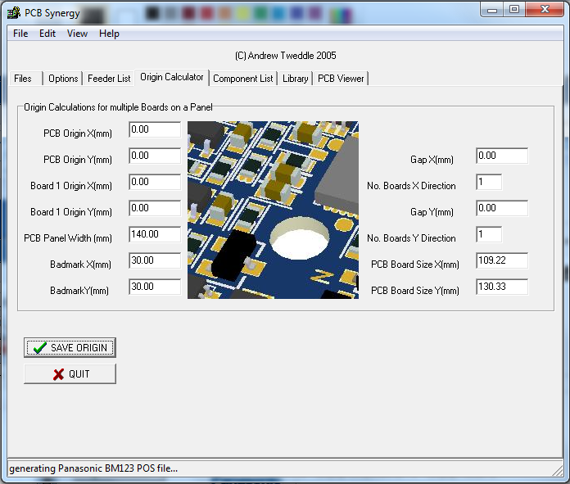

This Dialog box is to generate a set of Offsets for the SMT machine for multiple boards on a Panel. The measurements have to be taken from the PCB file that would be generated by the Circuit Board manufacturer. Or alternately using a Vernier caliper on the boards that you have had made. (Not the recommended way as little mistakes make for components that may not centre very well when reflow soldered.). This only works for some of the output formats. There seems to be no easy and consistent way to extract this data from a Protel PCB file, so it must be entered here. The Pitch is the distance between boards including the actual length and width so board1 is (0,0) board2 (length +10,width +10), in the example screen. With 3 boards in the X direction and 5 in the Y direction, we have a total of 15 boards on each Panel. The Badmark is where a sticker or paint mark is placed when a panel has a faulty board (ex. The board didn’t etch properly in manufacture, but the rest of the panel is OK).
The PCB Board Size would normally be extracted from CAD data, but when using PCBCSV or PIK formats, it can be entered here.

Component List Screen
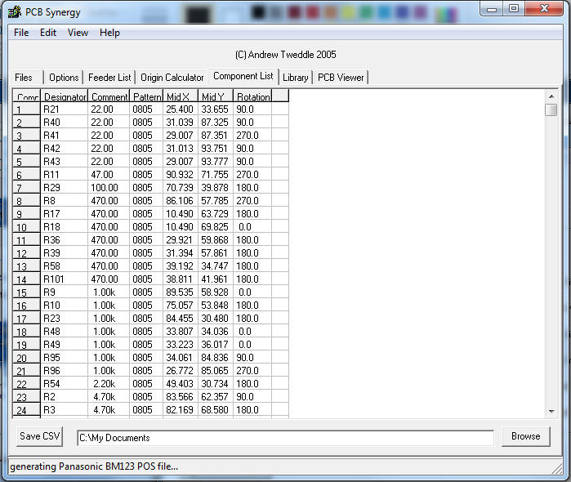
This is a new Screen introduced with version 1.0.0.16 to give the user a chance to look at the XYR data generated within PCBSynergy without have to open a PIK or CSV file in an external Editor (like Notepad, Ultraedit etc). In line with my stance on QC this data is not directly editable. However it can be saved to an External CSV file for comparison/editing purposes. The XYR's are the same as the generated PIK and PCBCSV files.

Library Screen
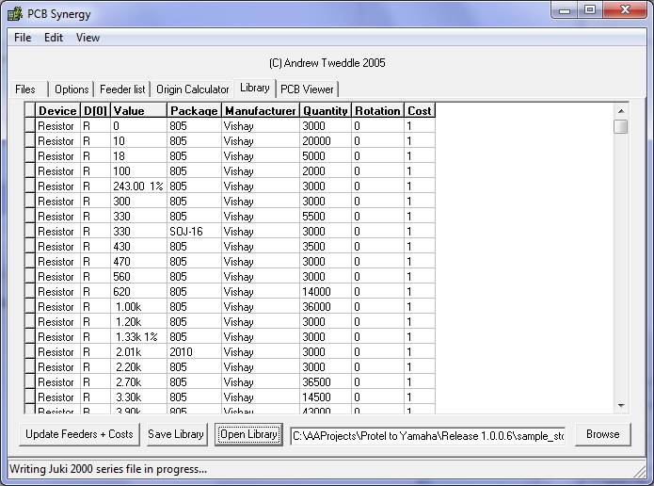
This Dialog opens up most Excel CSV files. For a CSV library the file needs to contain a first line of column headings with Device, D[0](The Device first letter/Designator type), Package, Value, Quantity, Rotation, and Cost. The other columns are SMT machine or user specific. The following rows then need to be the appropriate numerical or string data. The Update Feeders + Costs Button then needs to process each component row and compare component by component in the internally generated feeder list. To add the costing and other data to the On-screen Feeder List. How does it do this? This program was developed to simplify the problem of getting already designed PCB’s to manufacture as well as cost optimising a Schematic before the PCB is laid out. To this end some thought went into this function which for a human operator is simple. The Protel PCB footprint is generalised and a string comparison is done between the library package and PCB footprint so that 0805 in the library is considered the same as 0805(IPC), 0805(spaced), 0805(thin), 0805(wide) etc. Capacitors, resistors and inductors are treated as having a real value, so 6.8pF is compared to the library and 6.80pF are the same. Integrated circuits are treated as having string names and a comparison is done on this. Diodes and transistors are compared on an appropriate string subset so SOT23 is the same as SOT23T, SOT23D, SOT23CBE etc. IC Packages are compared with appropriate character deletion so SO28 is the same as SO-28. Many other subtleties are built into the software to make it as human like in it’s naming and comparison functions. Extra columns may be added to the CSV file for clarity or other uses, but this will not impact on the built in functions.

PCB Viewer Screen
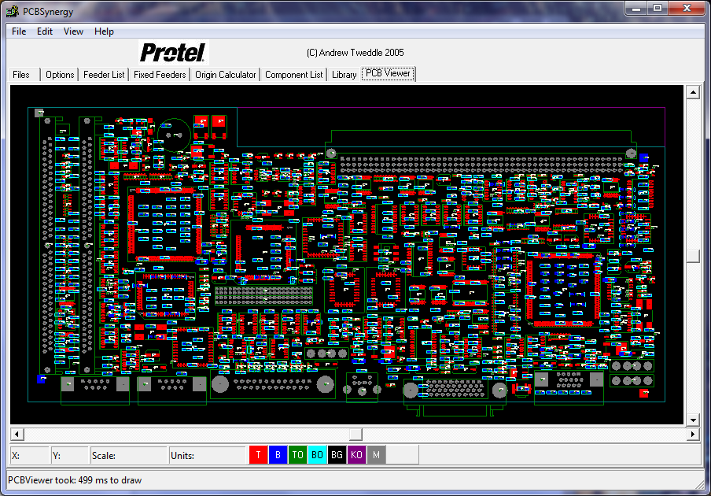

This is the new PCB Viewer Screen. To use this Viewer:- Process a file (so we have something to draw), Select the PCB Viewer Tab. The screen is initially centered. Move the slider buttons for horizontal and vertical scrolling! PageUp and PageDown, Zooms the drawing. At the moment it displays, PCB pads which are overlaid with a dot on the centre of pin1, the pickup location for the component and it’s direction signified by a small blue cross with an arrow on the tip which gives the direction. and component and board outlines. Each component is named and component pad is numbered. The squares at the bottom give the legend for the layers similar to the Protel default arrangement. Red being Top, Blue for Bottom, Green for Top Overlay, Light Blue for Bottom Overlay, Black for Background, Purple for Keep Out (Board Outline). and M for Multilayer.

For this first release the application has had registry saving of screen settings, Options, file locations etc in HKEY_CURRENT_USER. When you Quit PCBSynergy, your settings are saved. The Uninstaller doesn’t remove the registry settings. If you have troubles when installing a newer version just hand delete the old Key using the Windows Registry Editor (Regedit).

The Power of PCBSynergy: - Split files - Multiple Machines

PCBSynergy can be used to generate split files by first saving a suitably generated file to PIK format or the new PCBCSV Option in Manufacturer TEST and then taking this file and splitting it in two or three using a text editor. The files are then re-read into PCBSynergy as PIK's or with a file extension change to CSV read in using the new CSV option. Similarly if you wish to do feeder swapping you can use the saveCSV option on the feeder tab to save and edit in a spread sheet or a text editor. The first row is feeder one, second feeder 2 etc. You swap the order around and then re-import using the openCSV on the Tab folder, then use the Save Feeders button to generate a changed SMT file.

Product Use and Function

I developed this program initially for my own use, in my very small electronics company, as there was no good way to go from design to cost optimization of a product to manufacturing on my newly acquired secondhand SMT machine. I knew that it took the best part of 2 months every time I did a product turnaround from an almost completed design to product in my hand ready to sell and maybe $20,000 in outlaid components. Then factoring in the design time on some of my products, 6 months to a year. Part non-availability, when a component shortage hit. This was small potatoes for a large firm, but for me a surefire business disaster waiting to happen. Some thing had to give. Talking with friends, with other small electronics businesses, lead me to design this program. I noticed that Protel (the dominant player in CAD in Australia) was hopeless in this area, as it had no easy way to export its output files and then automatically cost the product as you designed it. This is why I came up with the automatic CSV/BOM File, and The NA (Not Available in Stock) CSV/BOM File. I could dump the file and get on the phone to the local suppliers and send them a list with only what I was interested in purchasing (not my whole design). Later on I purchased an old machine and got it ready to use.

I use the program by having Protel open. I draw my schematic and then Save to ASCII text. I then do a cost analysis of the product, from my library file of components using PCBSynergy. If any components are not in the library, I go out on the web and add the price to my stock. Sometimes, I draw multiple sheets with different approaches to the same design using different IC’s. When I am reasonably happy with this I go to my local suppliers for Costing and Availability, Sometimes they come back with a suggested alternative because a local manufacturer is running big volumes on a similar IC or component. I then do the board design knowing I have a reasonable chance of making money, if my product sells.

This program has a very deliberately simple interface which as I develop it, I hope not to change much, as new functionality is added it will quietly add to usefulness without increasing difficulty of use. After all it was intended to be a productivity booster and more specifically a profit booster for those who have taken on one of life’s more challenging jobs, that of running your own electronics business, or working in a small one.

As I added more SMT output formats to this product, I was amazed at the number of formats, even from the same manufacturer (Juki /Panasonic). There seems little point to this from the users perspective as they all largely set out to achieve the same goals of placing components on boards with similar machine designs. It also has the unfortunate effect of making certain machinery redundant before the end of its operational life, or just too hard to generate a file for, or the manufacturer is out of business and your current $100K package doesn’t support your particular machine. I worked for a while in a major University in networking prior to the domination of IP. It was a nightmare of non-interoperable equipment. It would seem that a similar shakeup is long overdue for SMT machinery. Maybe a start would be a large manufacturer with a reasonably good format like Yamaha making it freely available to other manufacturers. Gencad and other attempts at interoperability seem not to have taken off. In the CNC world, if your machine doesn’t speak G-code it will be upgraded with a new PC controller and Servo drives and be back fitted with Mach 3 to give it a second life.

I hope you find this little application to your liking. I can be contacted at sarason@iinet.net.au for any bug reports or corrections that you may wish to suggest. Be sure to include [PCBSynergy] in the subject line.

